Greedy algorithm  
1) prim’s algorithm  
2) Kruskal’s algorithm  
3) counting coins  
4) knap-sot algorithm

Dynamic Programming [bottom-top approach]  
1)

Divide and Conquer [top-bottom approach]

Greedy method and not greedy method

Brach and bound algorithms   
Similar to divide and conquer but will conquer only some.  
1) Travelling salesman problem

Brute force algorithm

Randomized algorithm

Example-2: Binomial Coefficients

Principle of Optimality  
Solution 🡪 optimal and solution 🡪 not optimal [ what ???? ]

Longest Simple Path

18/2/2021

Back-tracking

1) try  
2) try expand

T(n) 🡪 1 + c1 + c1c2 + ….. + c1c2…..cn

**N-queen problem**

2 queens must be not in same row and same column.

4-queen problem (4 rows and 4 columns)  
2-queen problem (2 rows and 2 columns)

State space tree  
complexity 🡪 apply gp series

**Sum of subsets problem**  
🡪 state space tree  
🡪 promising sum of subsets

**M colouring problem**

**Hamilton cycling**

<https://www.youtube.com/watch?v=DKCbsiDBN6c>  
<https://www.youtube.com/watch?v=xFv_Hl4B83A>

23/2/2021

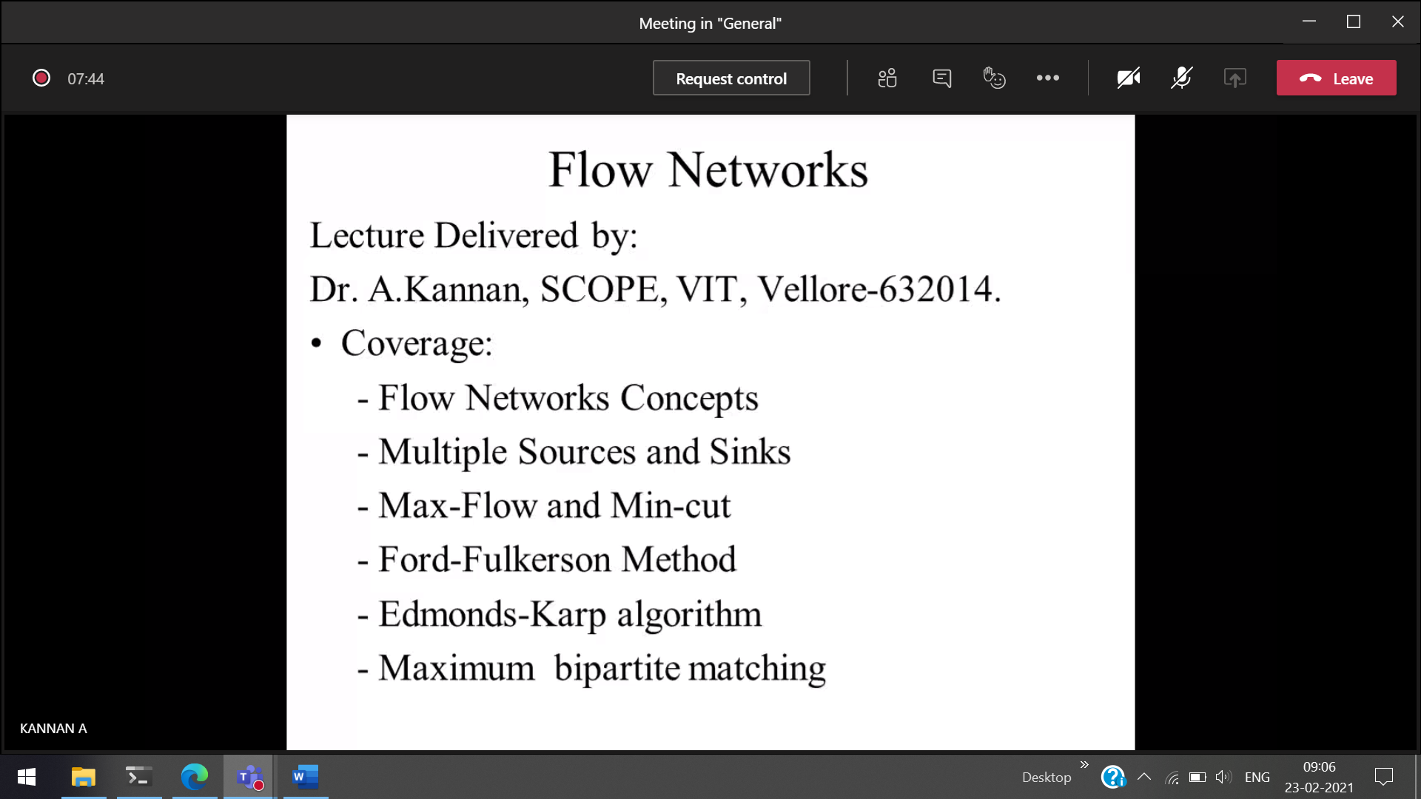  
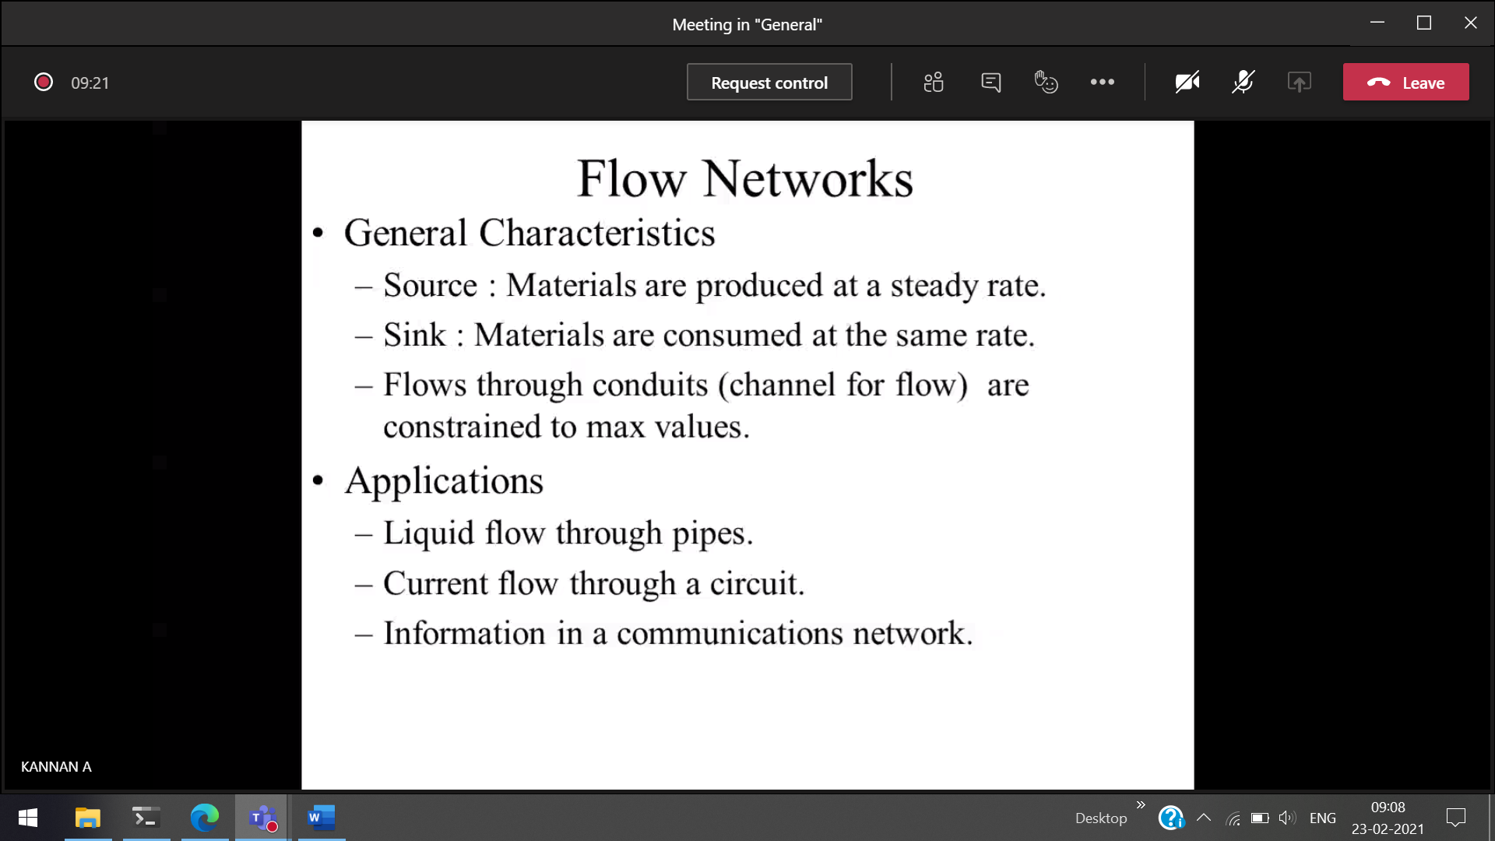

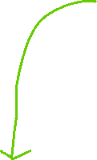

Capacity of the pipe is fixed.

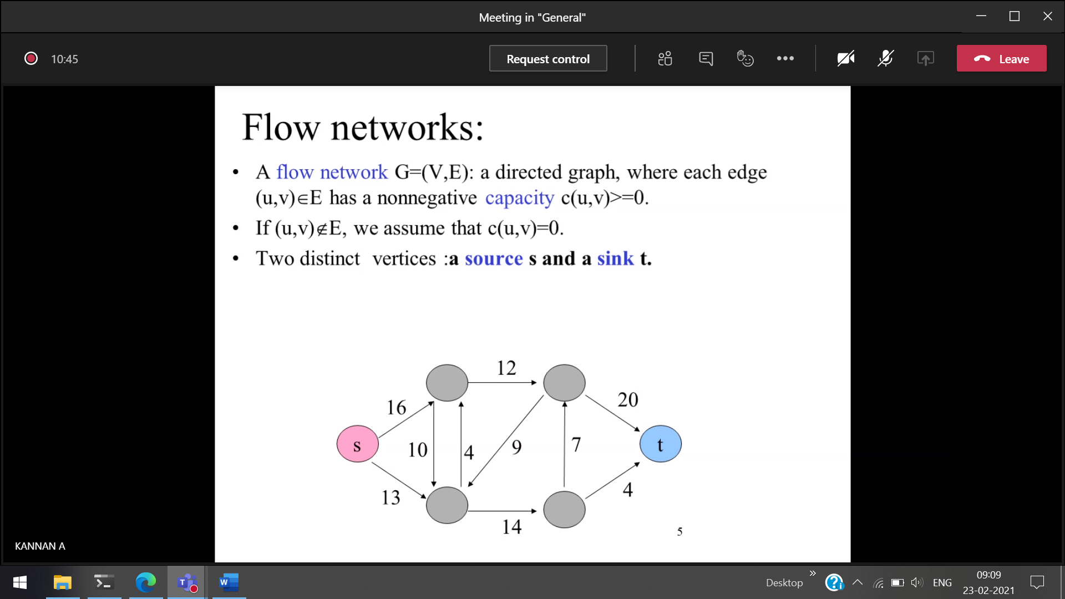  
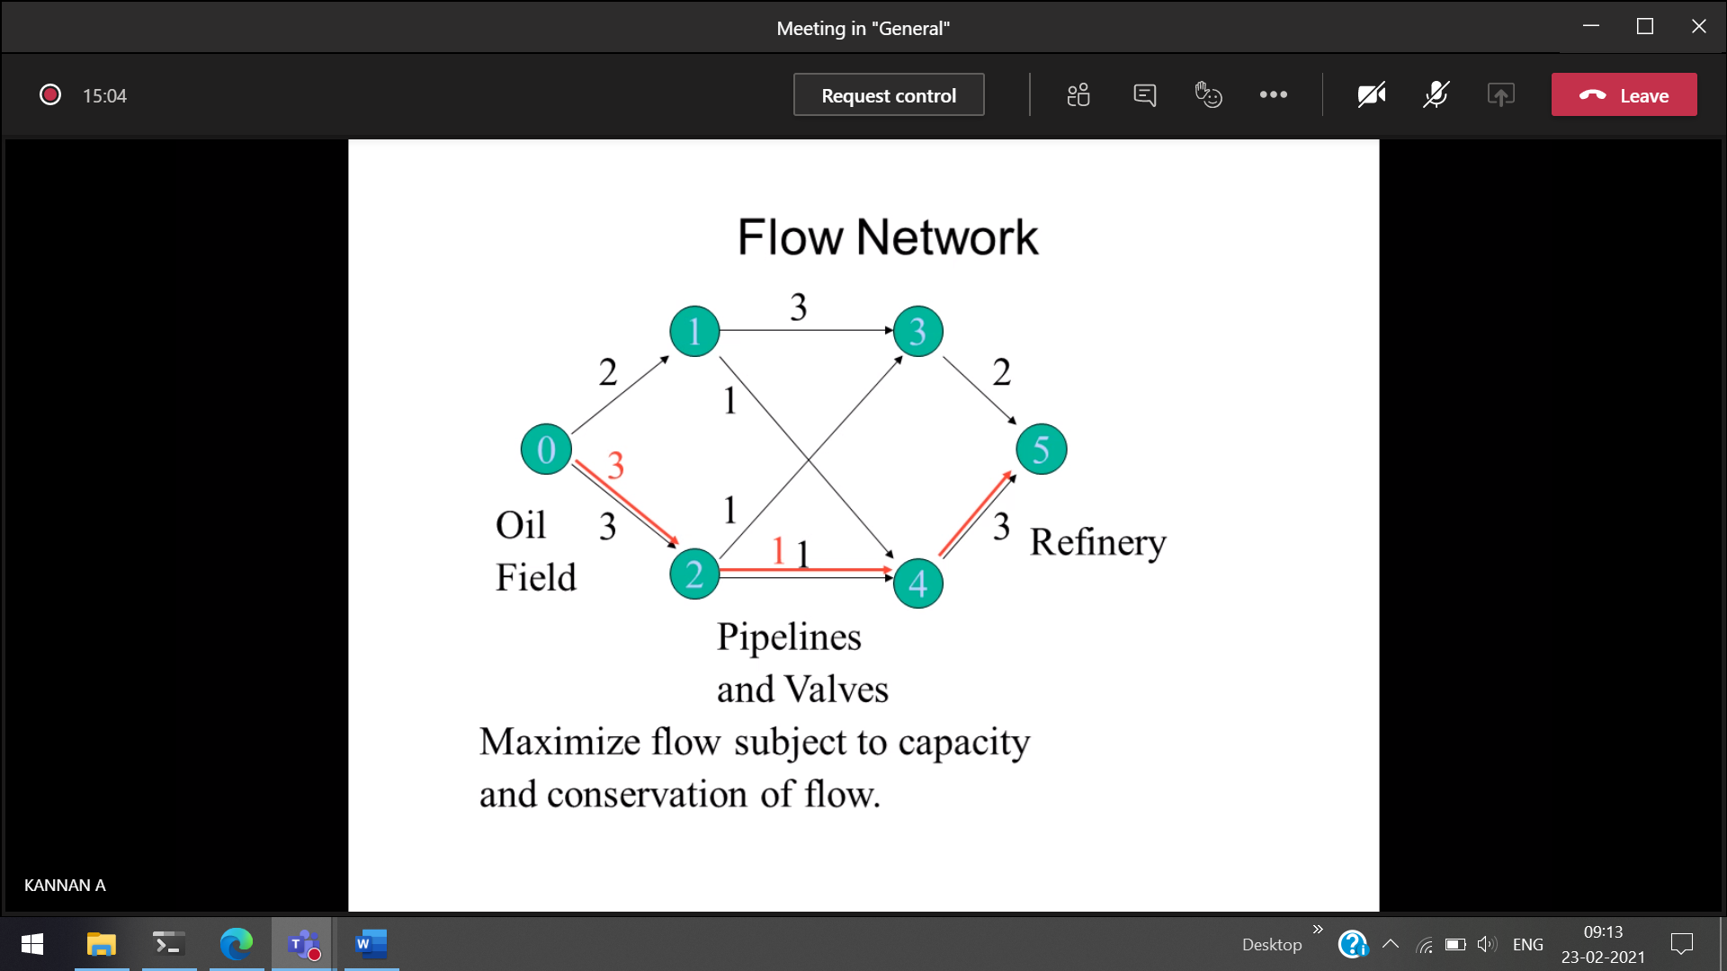  
3 is split into 1 and 1. So from 4 to 5 only <=1 can be sent. Since 2 to 4 holds 1.



Red 🡪 to be sent  
Black 🡪 capacity

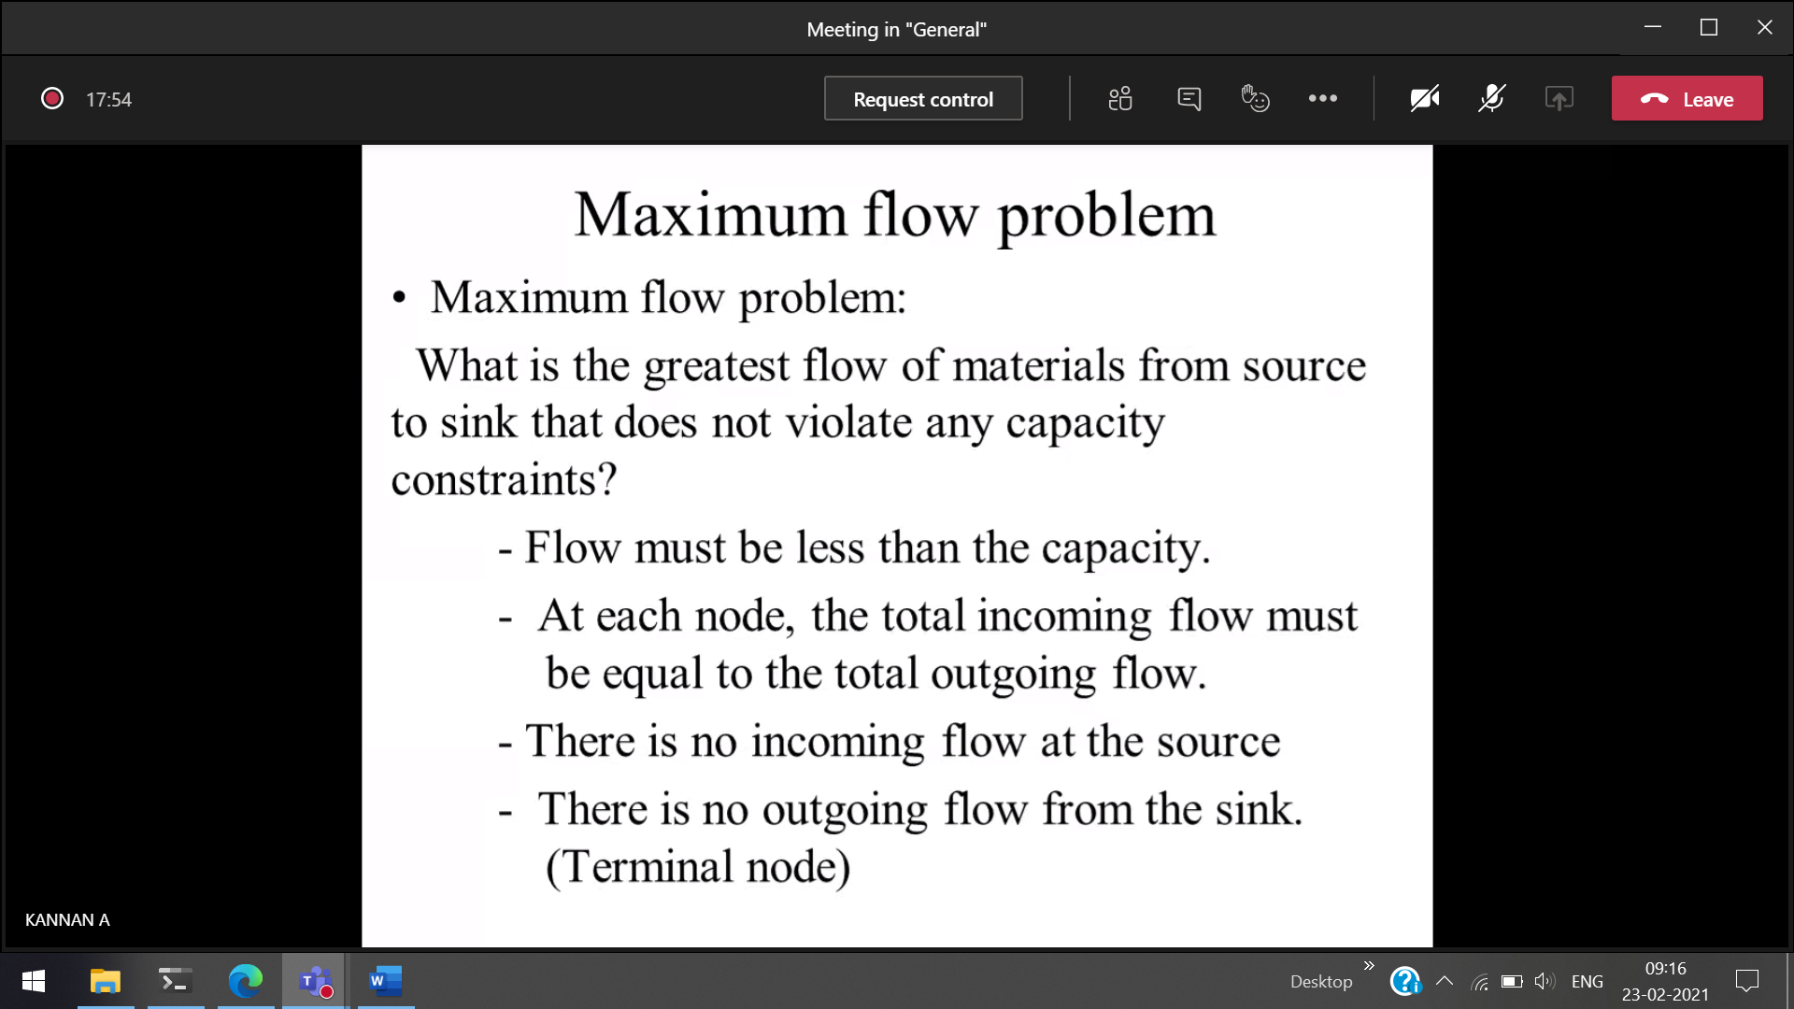  
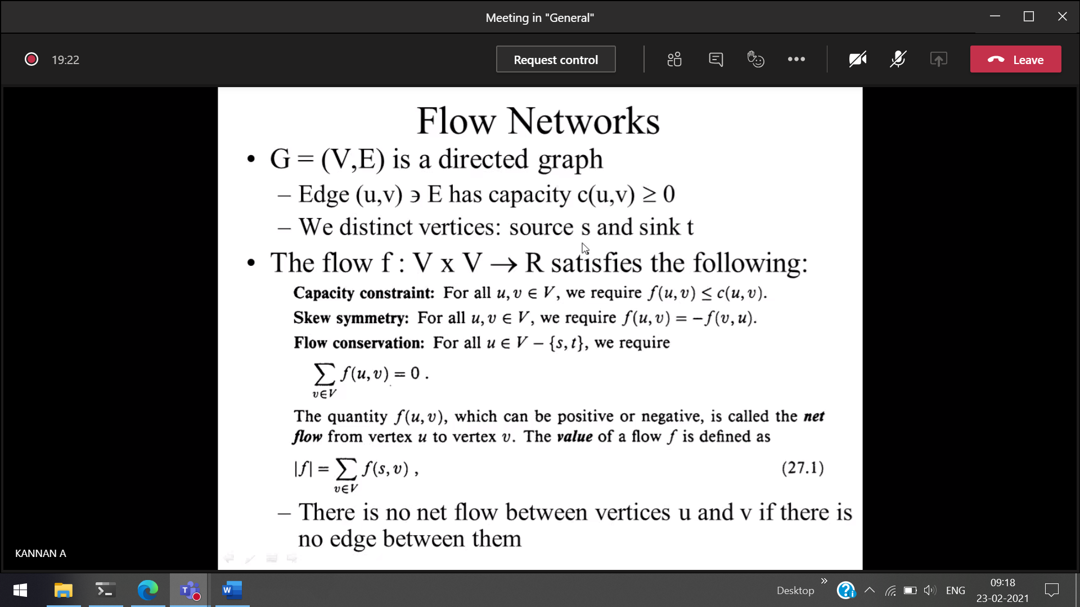  
5l of water from u to v.   
5l of water from v to u.



Inflow = Outflow



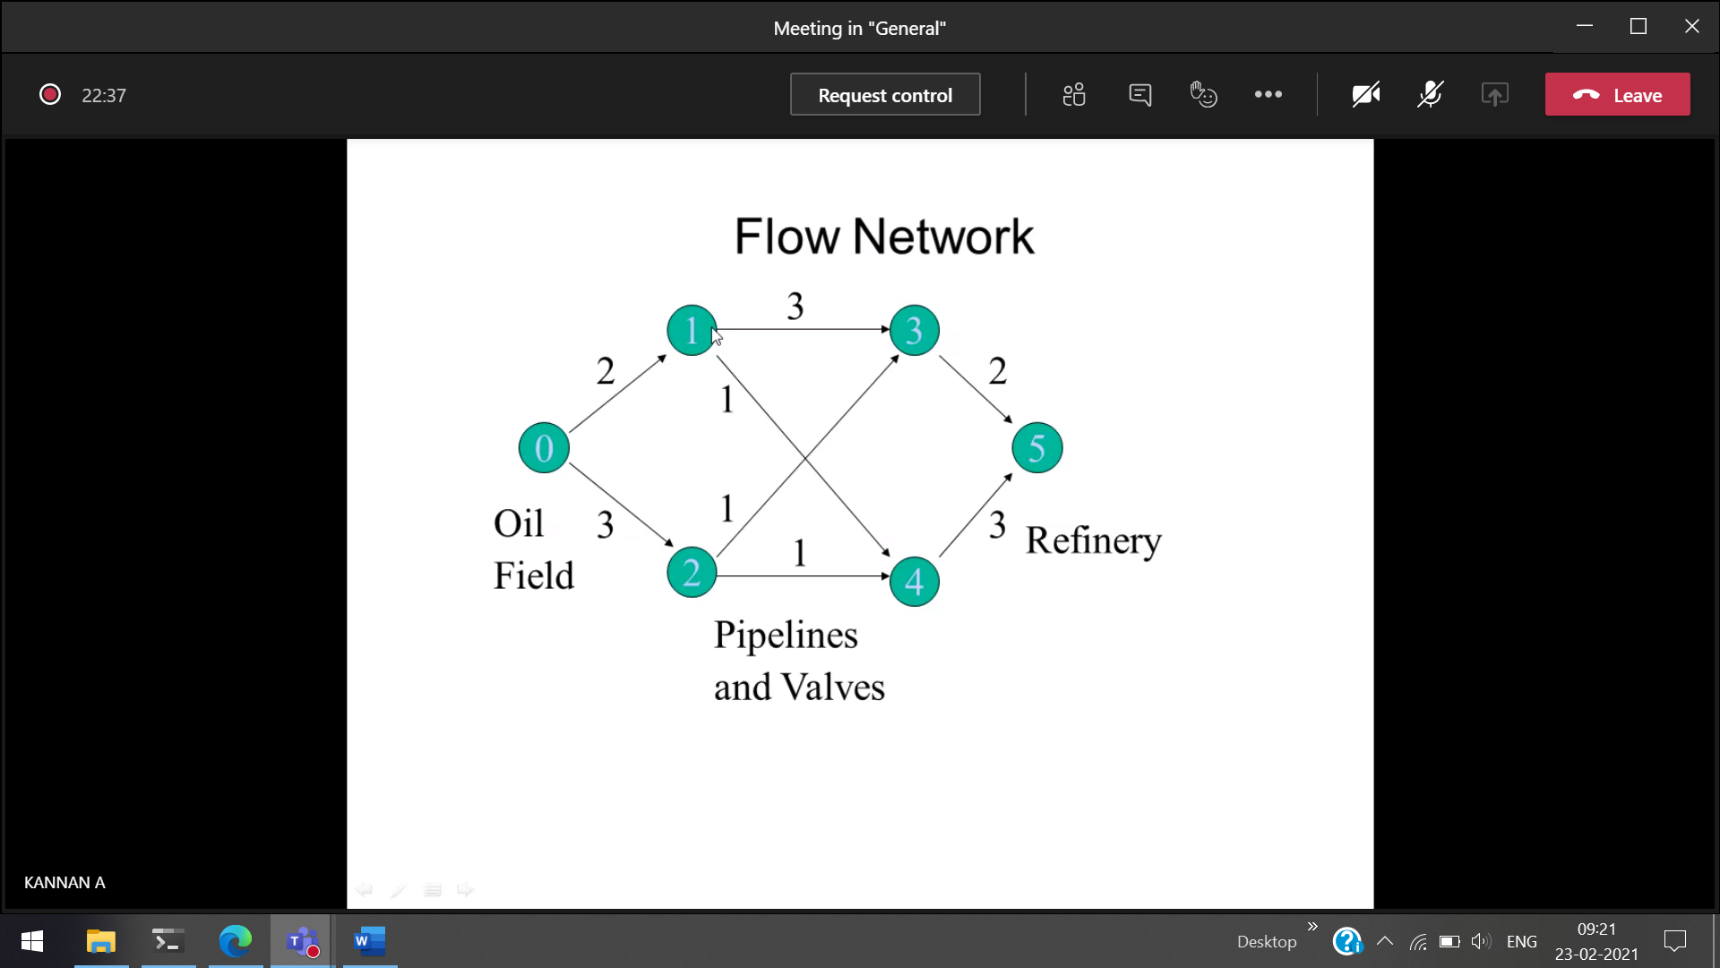  
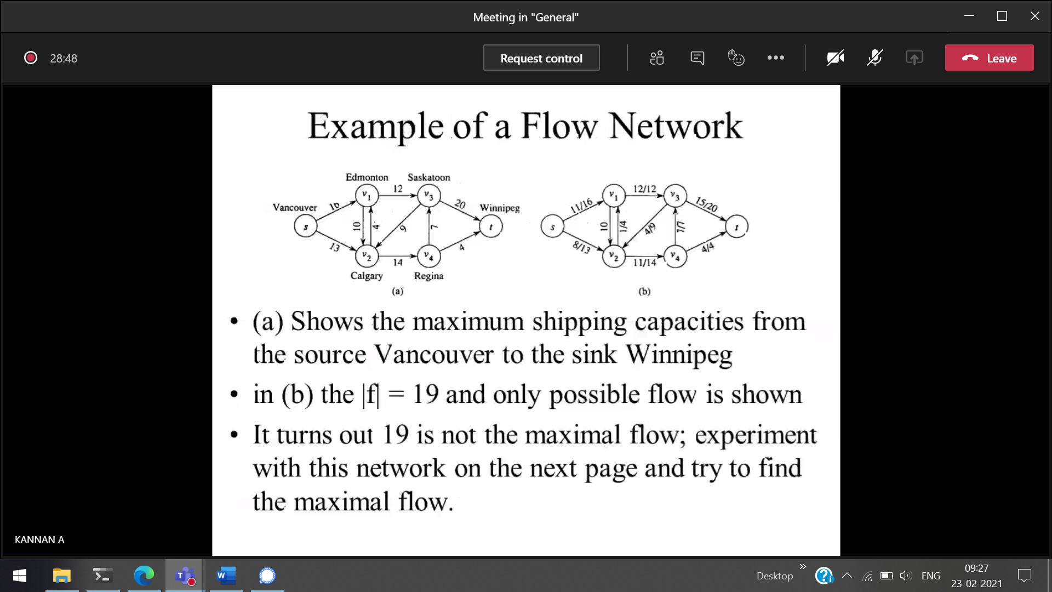



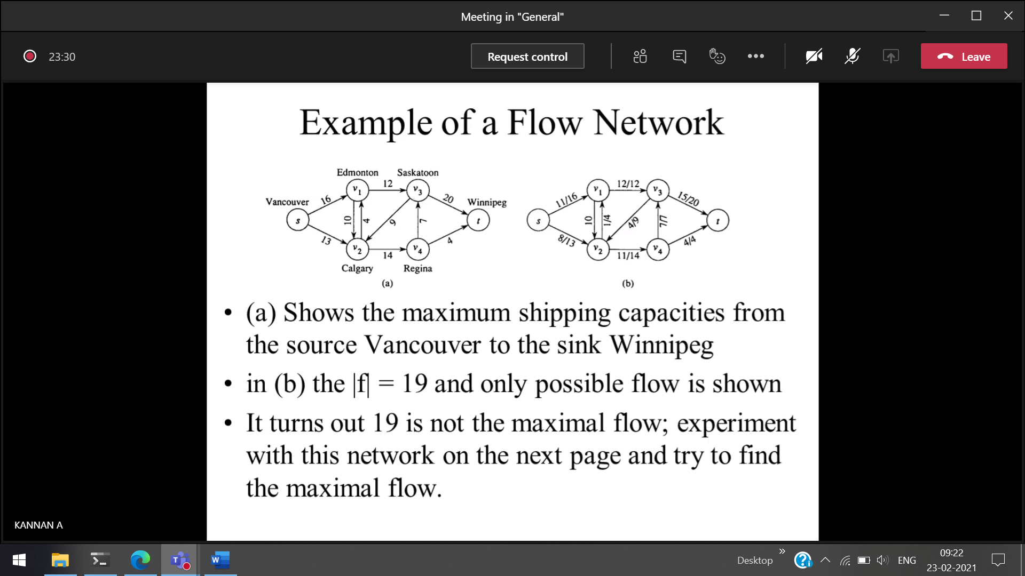  
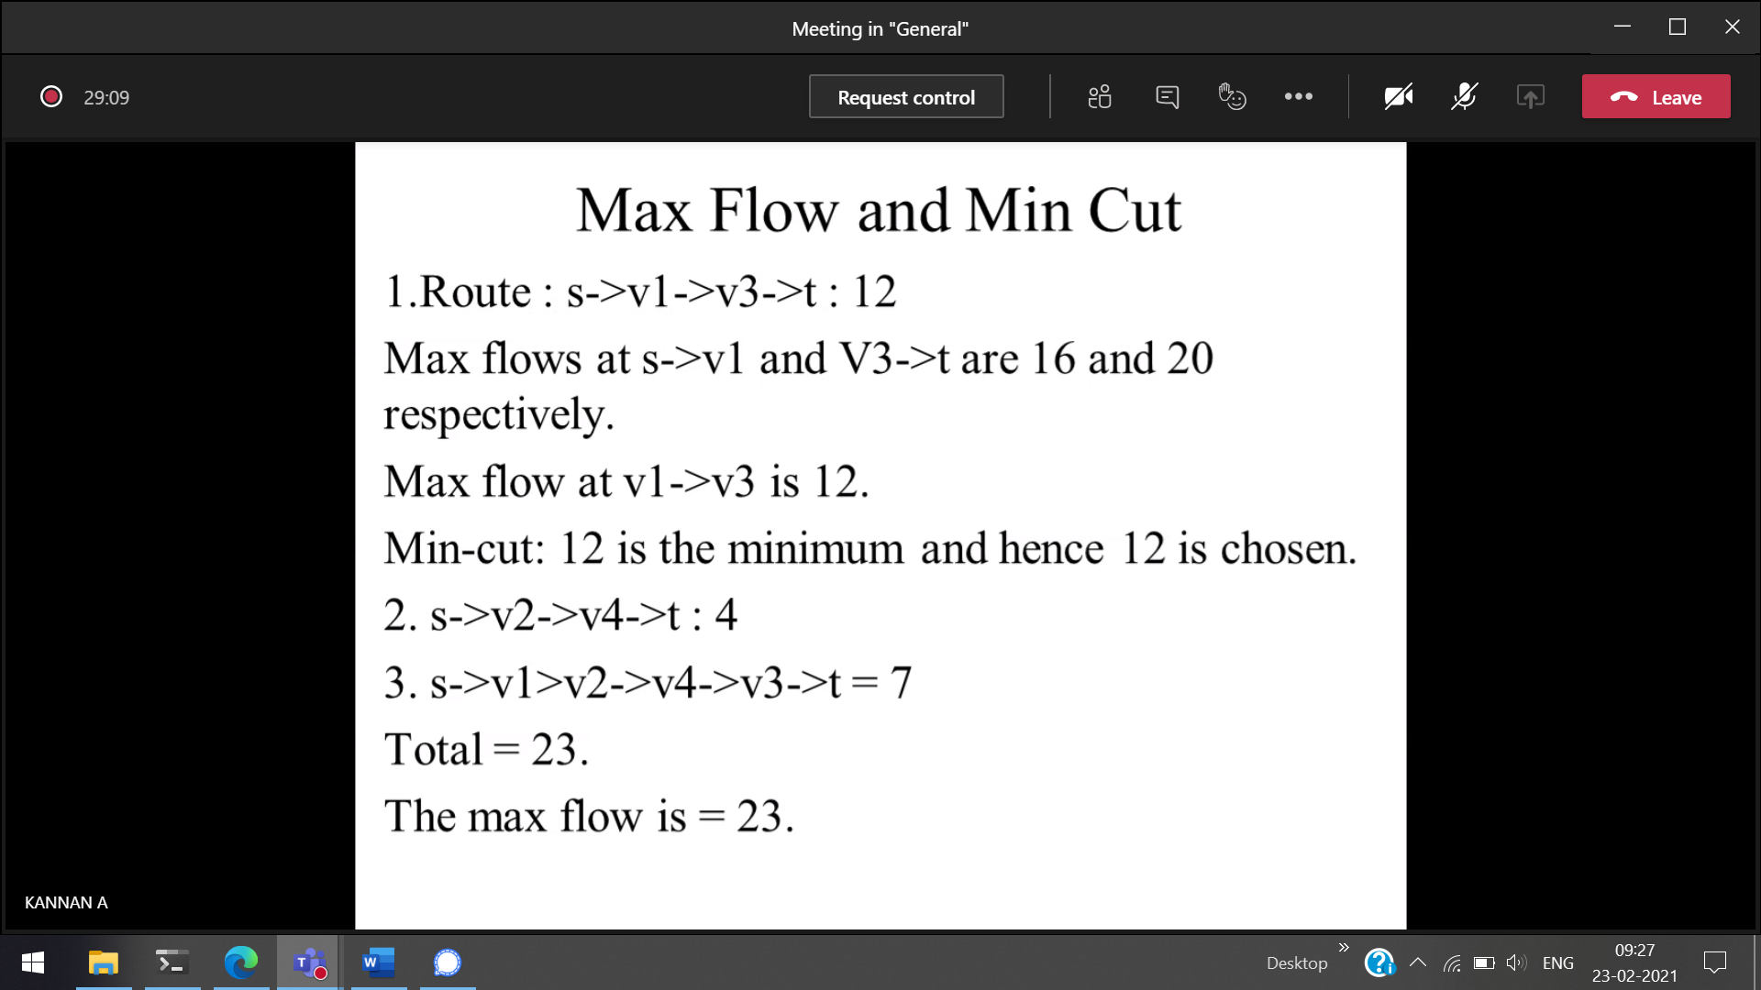

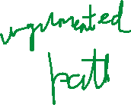

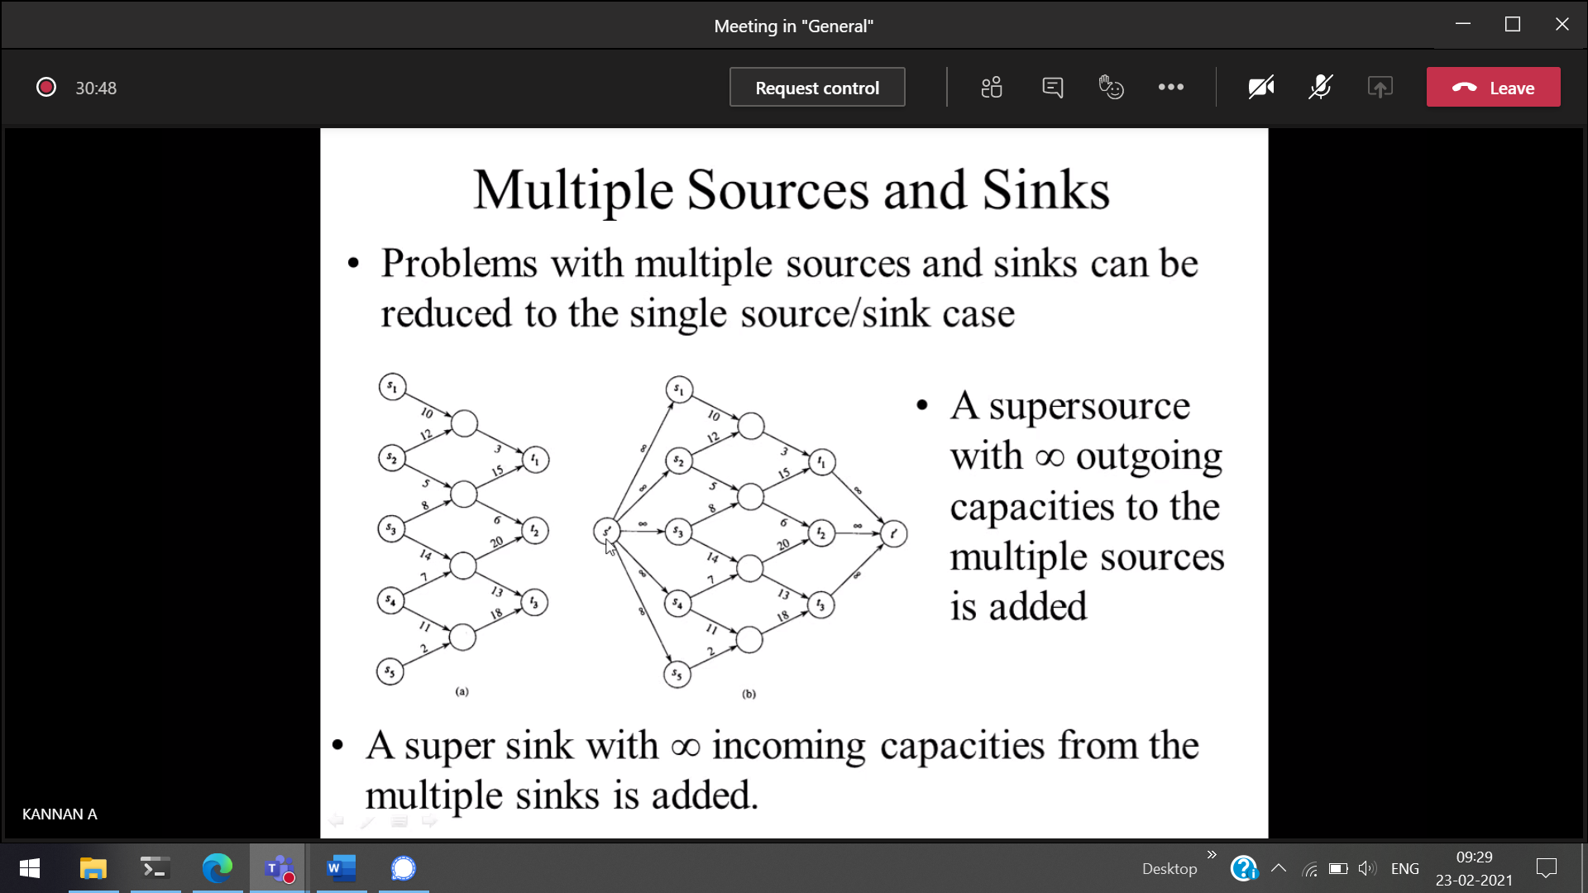  
multiple source, destination = single source, destination



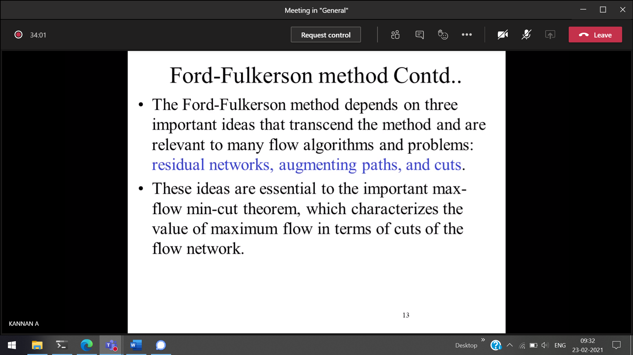

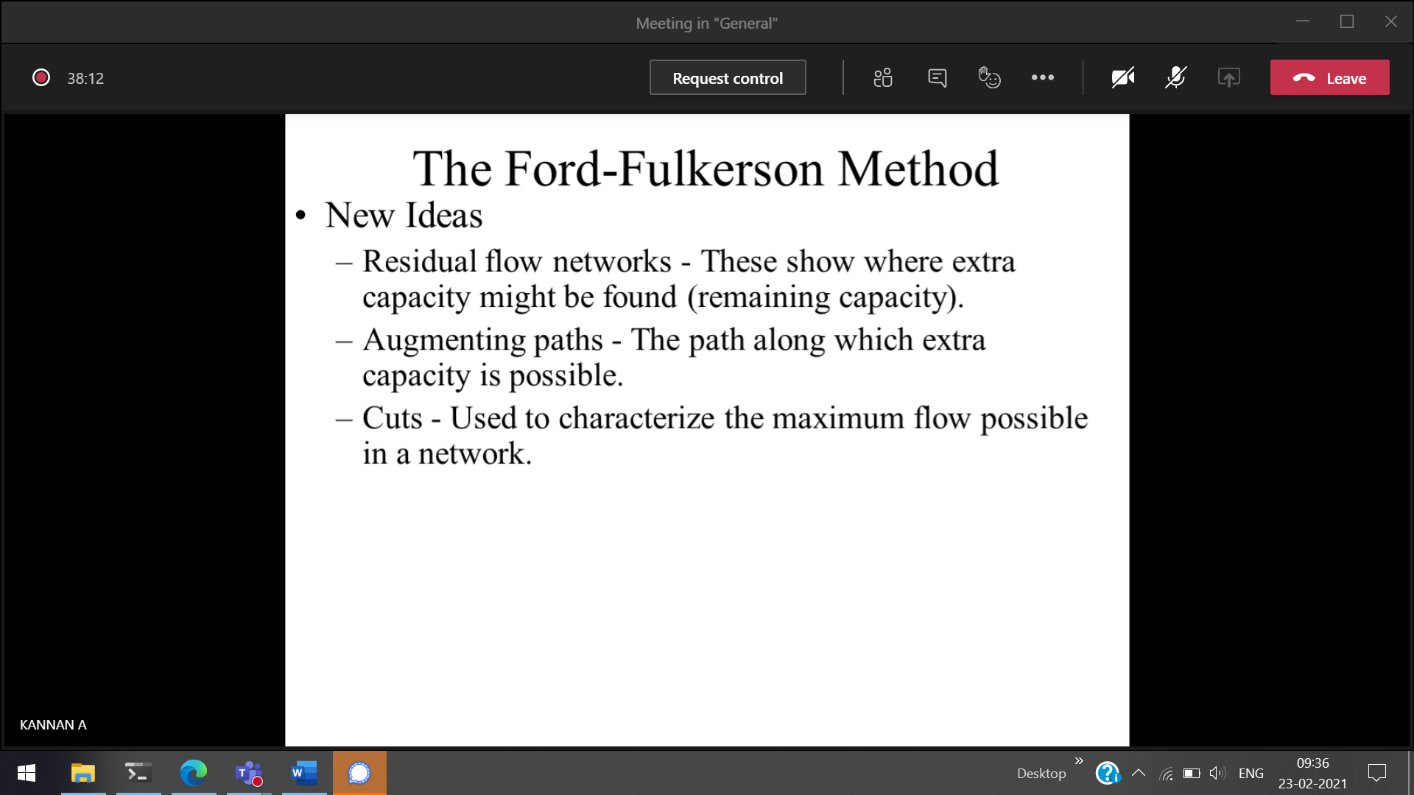

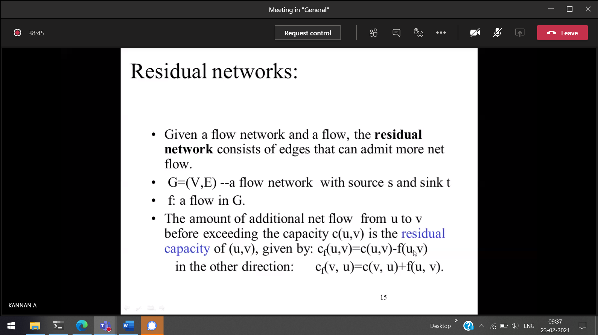



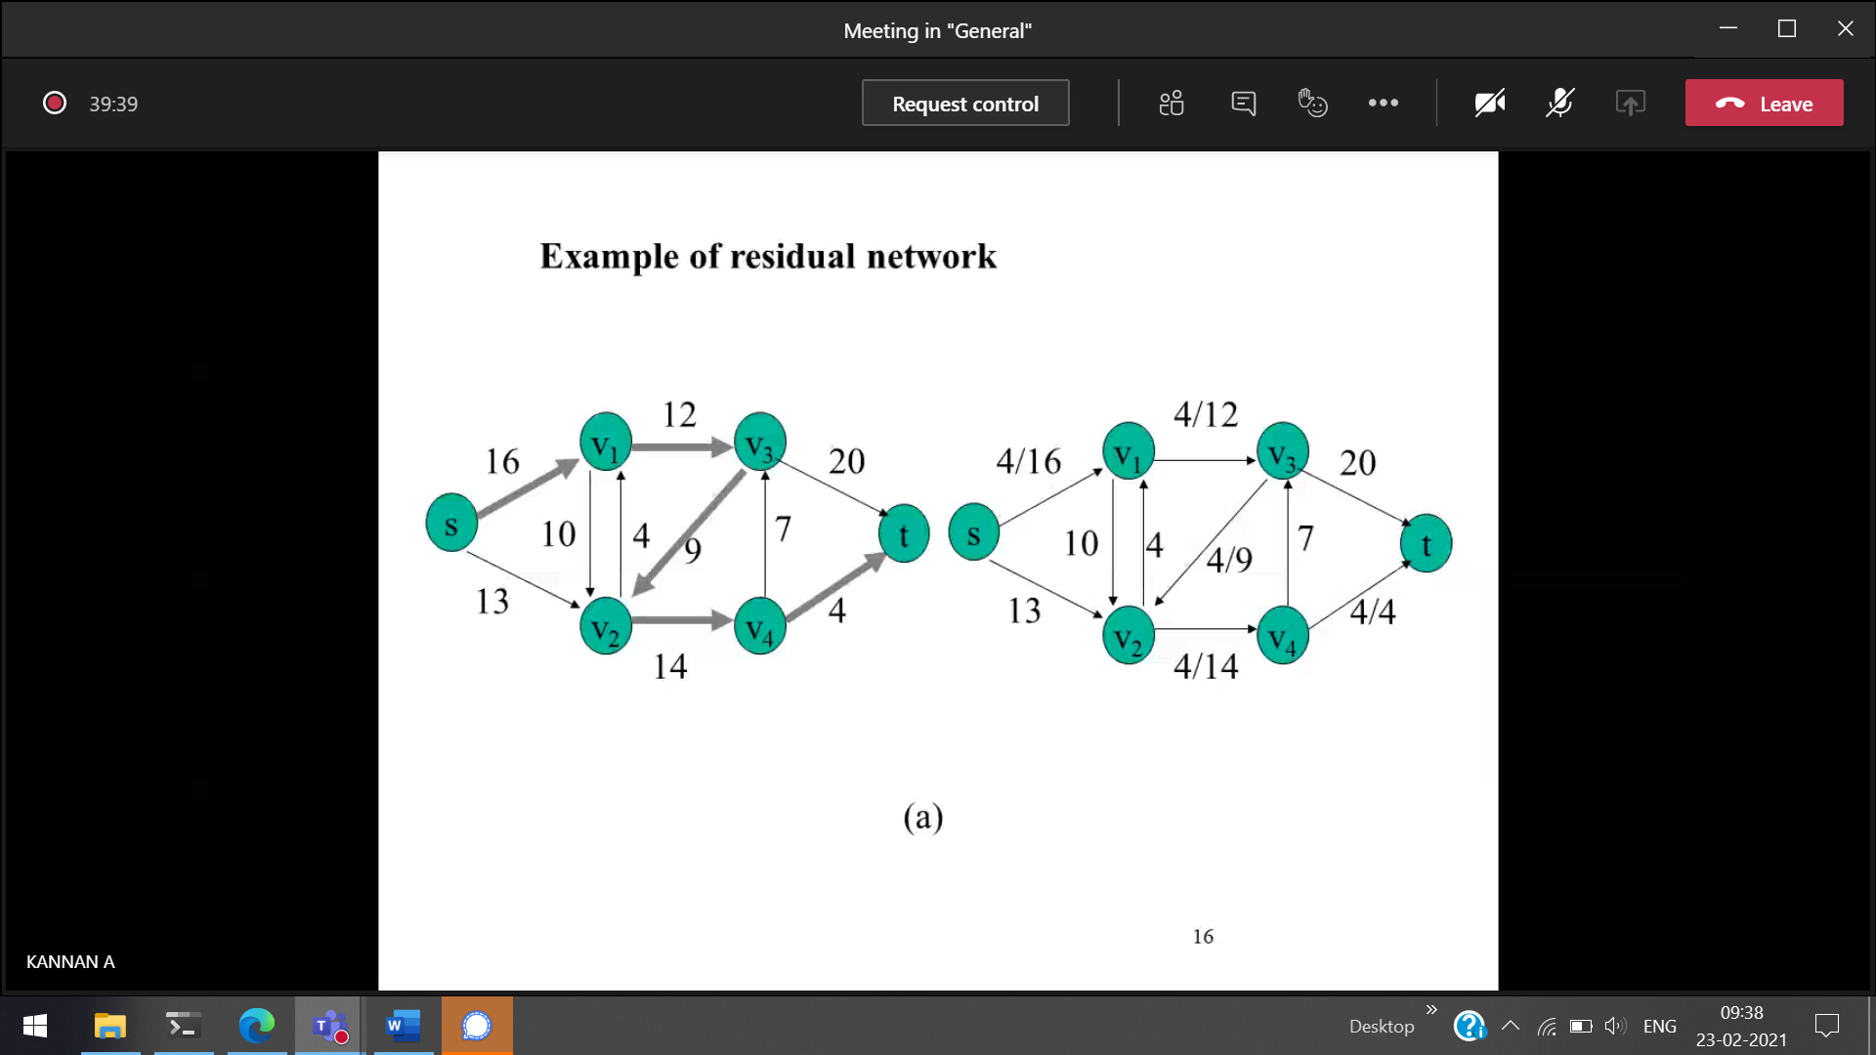  
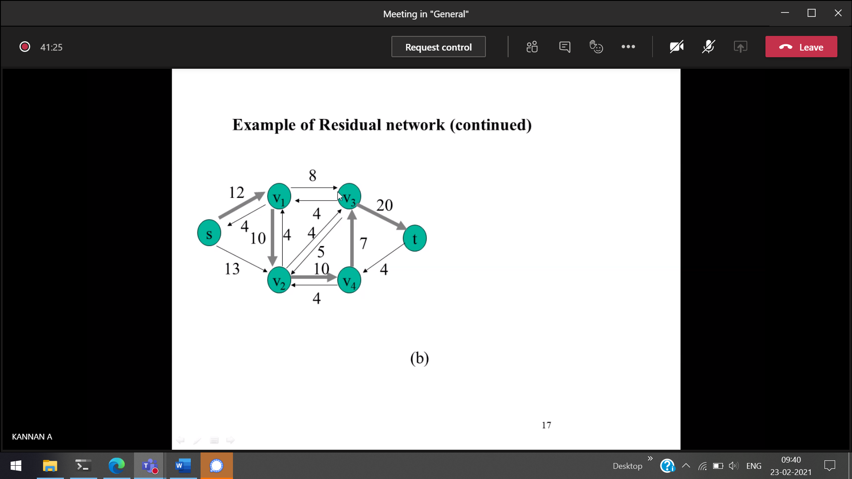

Residual 🡪 What values are there after sending

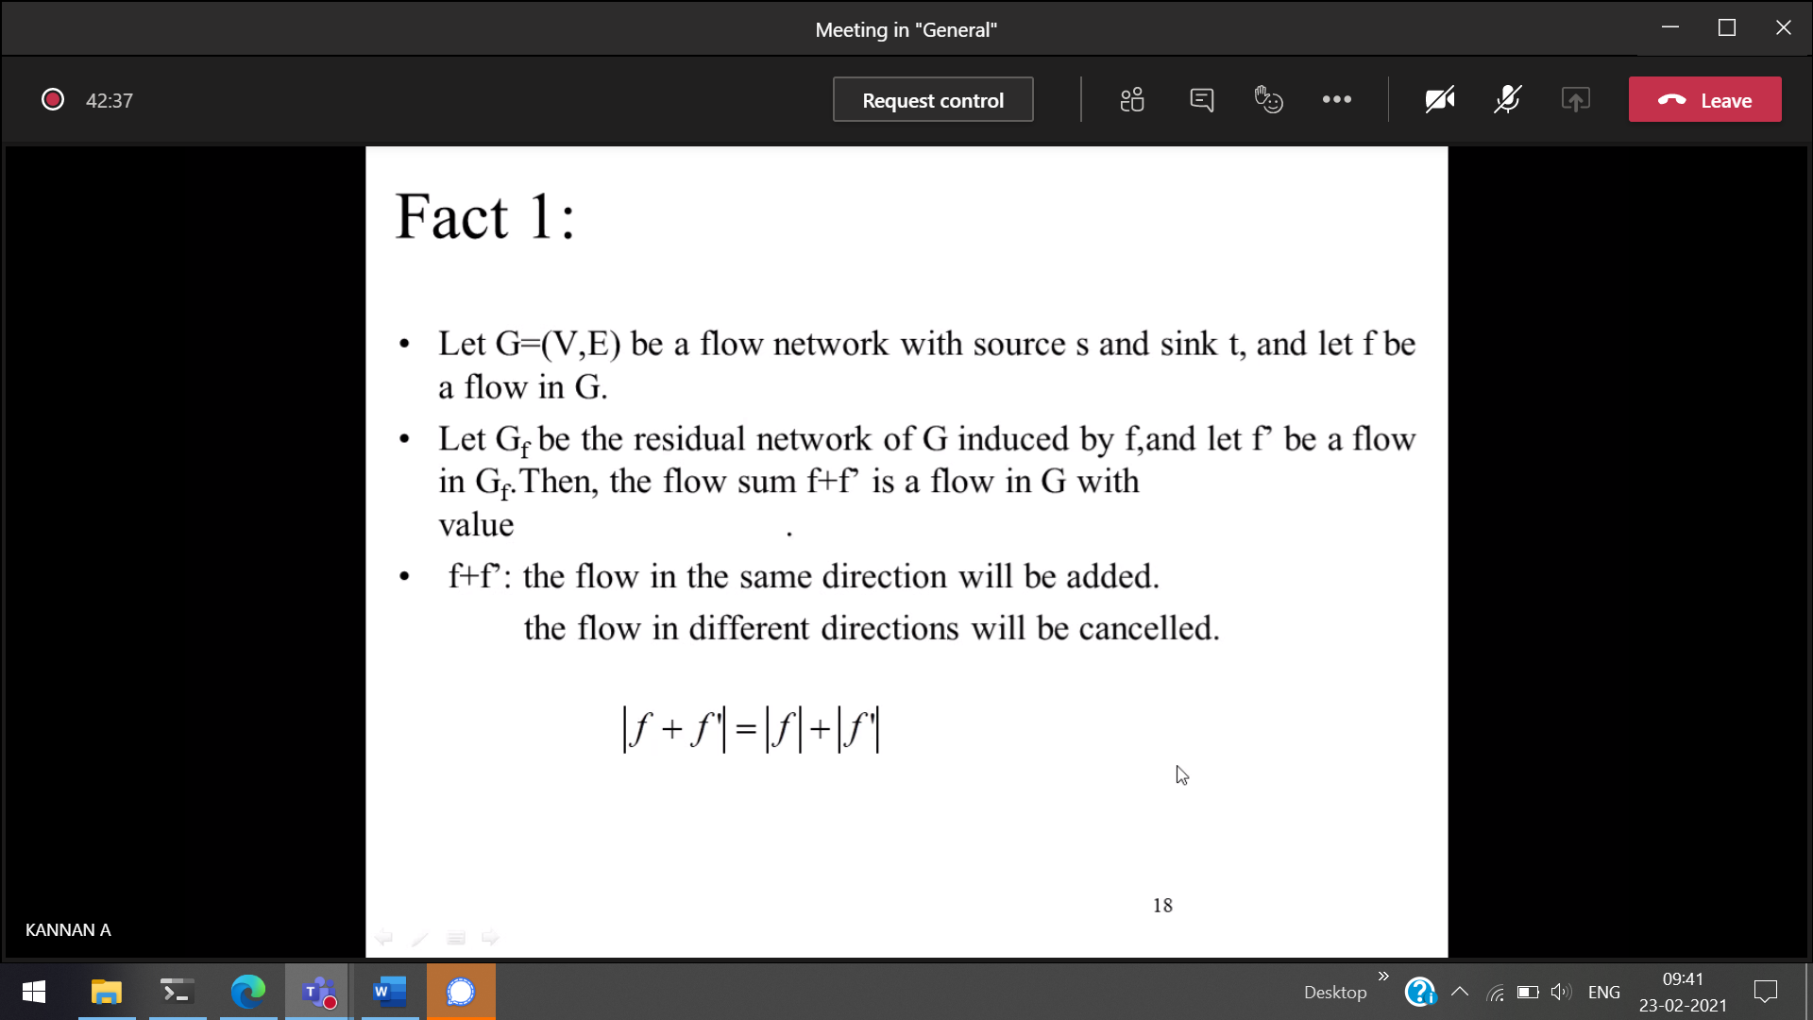

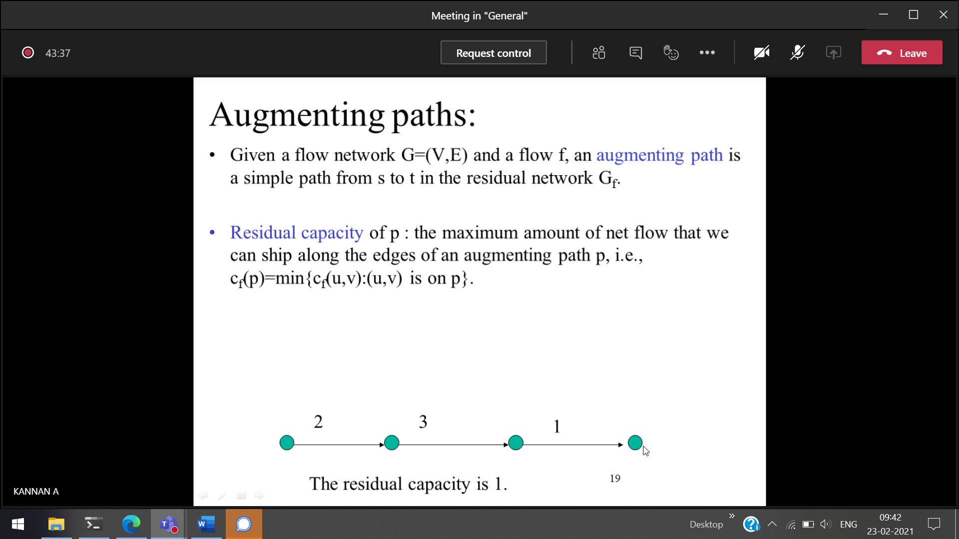

floyd warshall algorithm

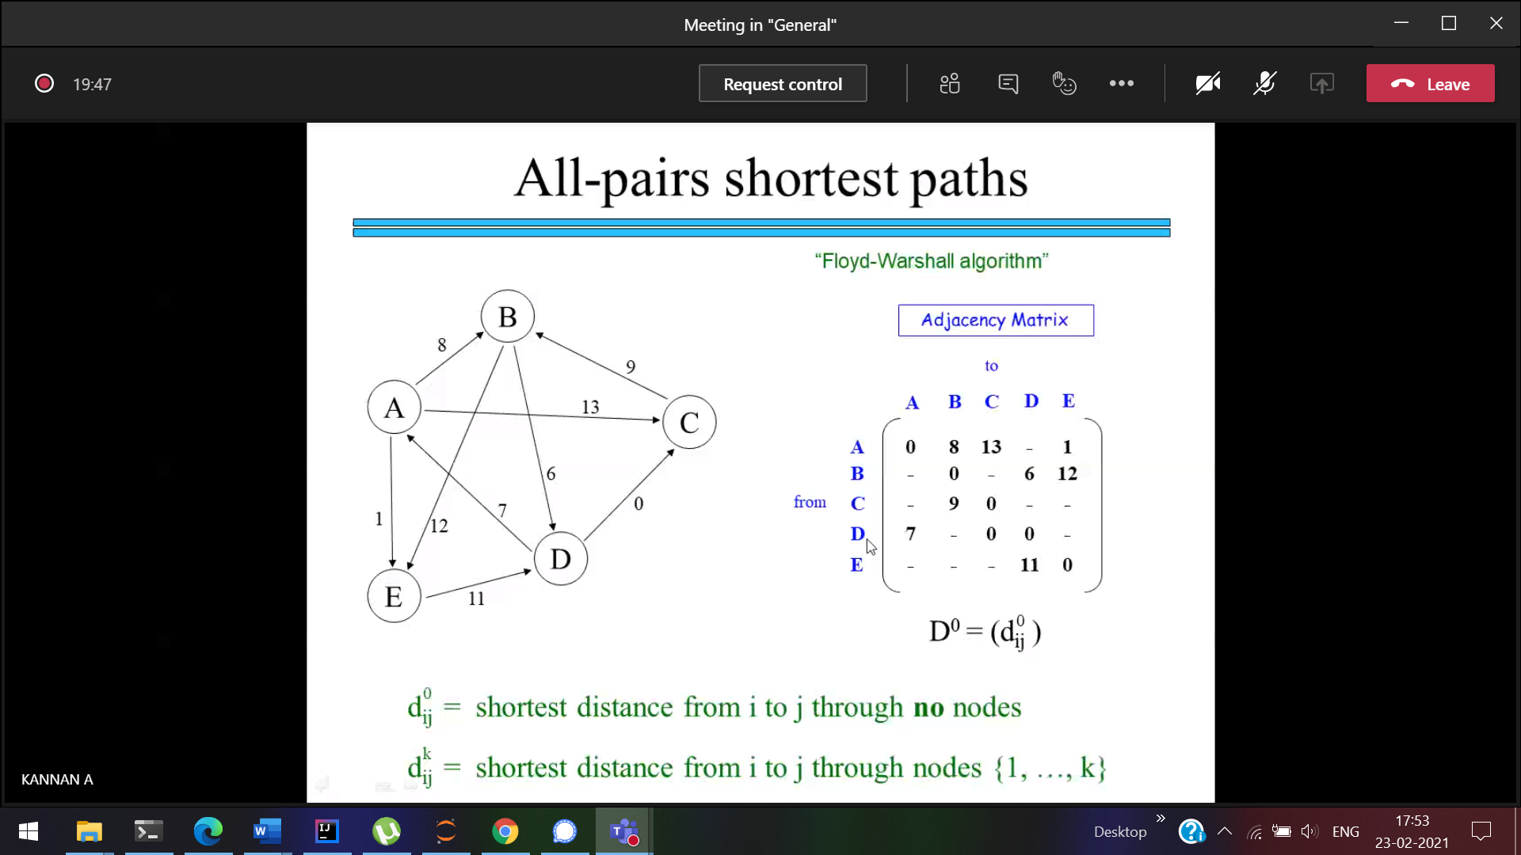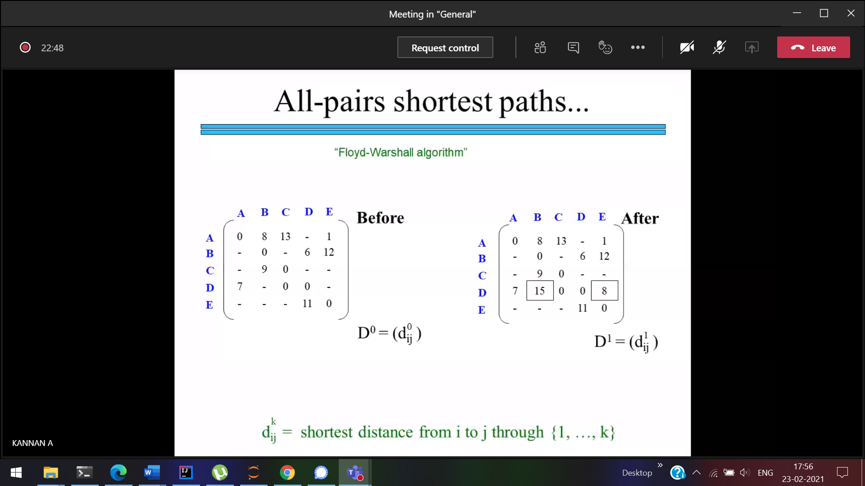  
D to A

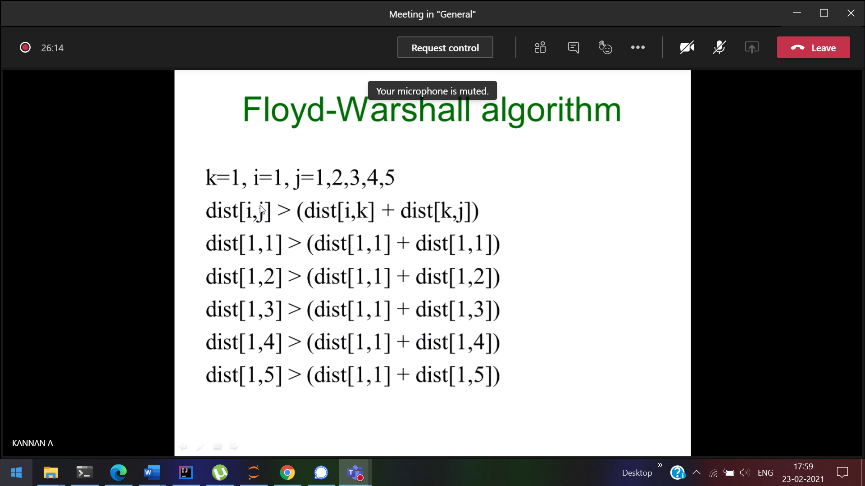

25/2/2021

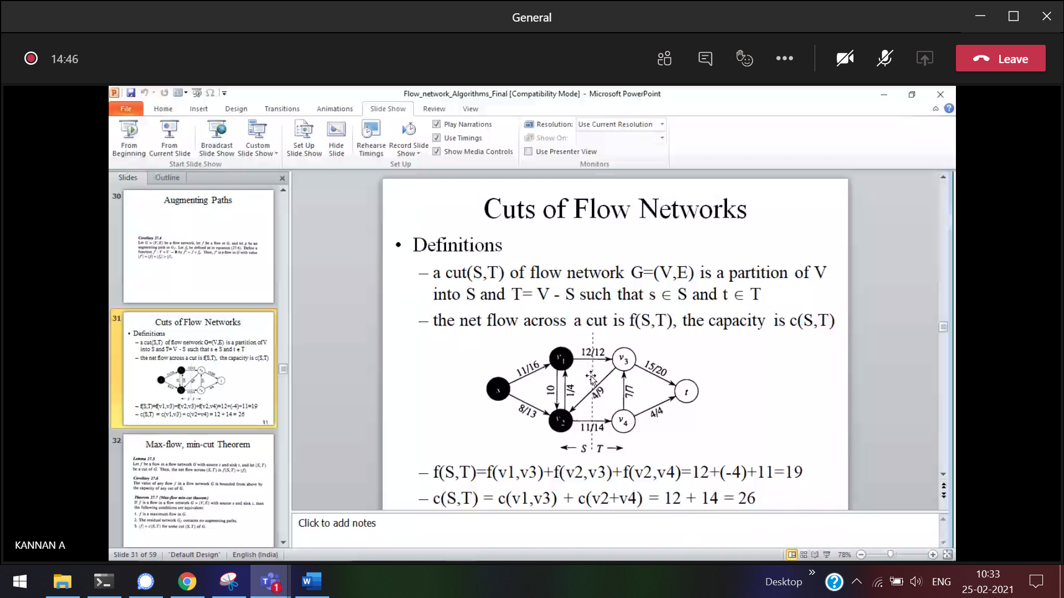

2/3/2021

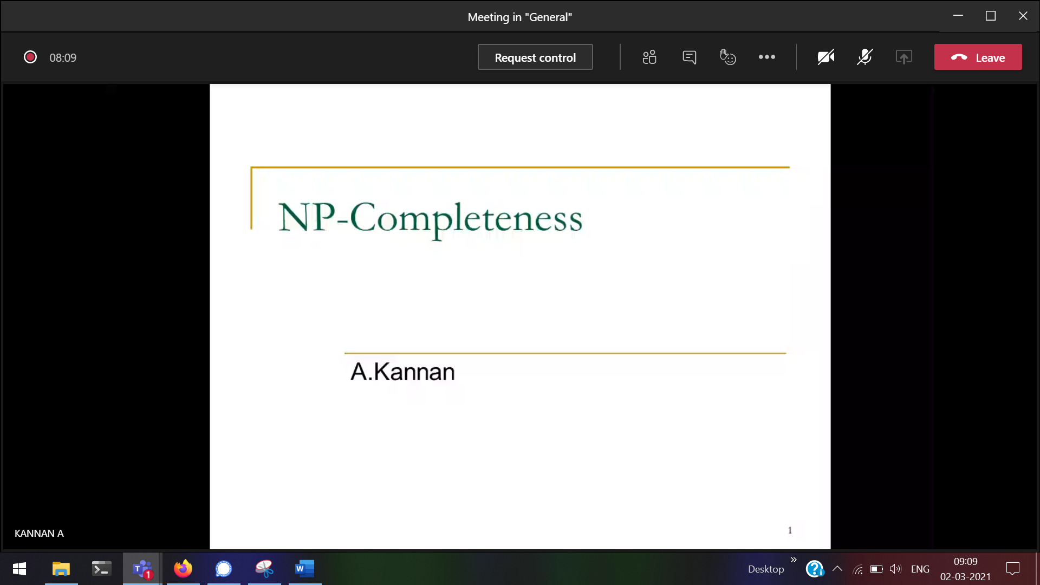

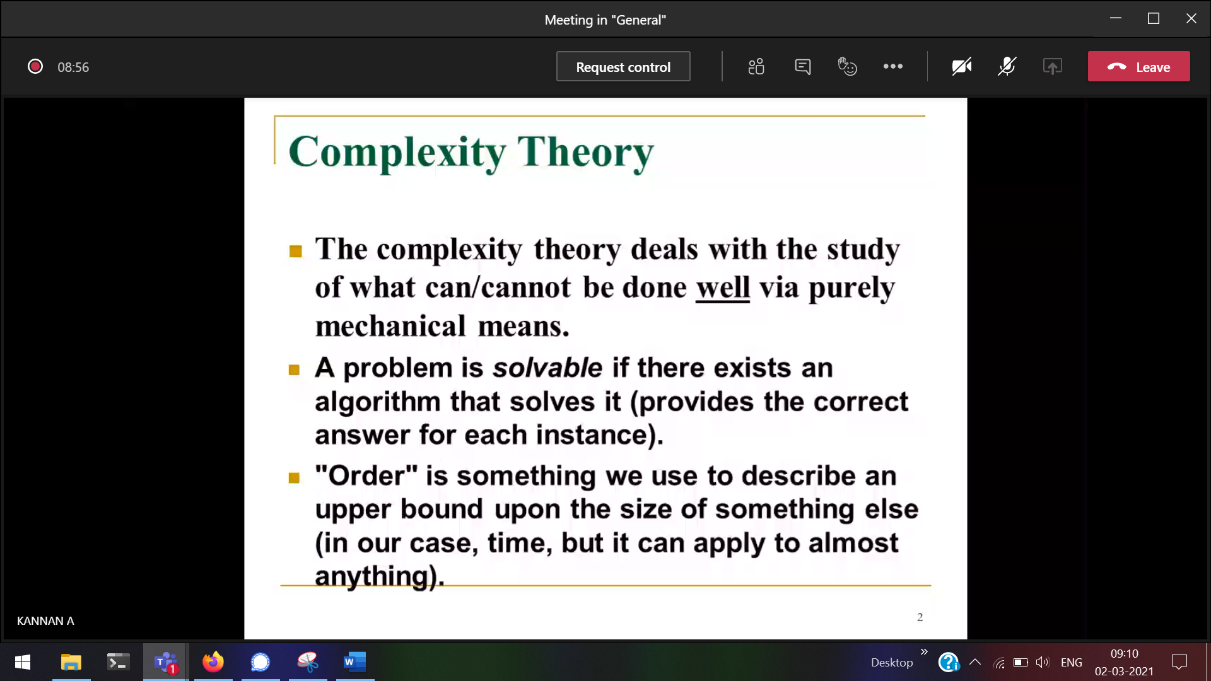

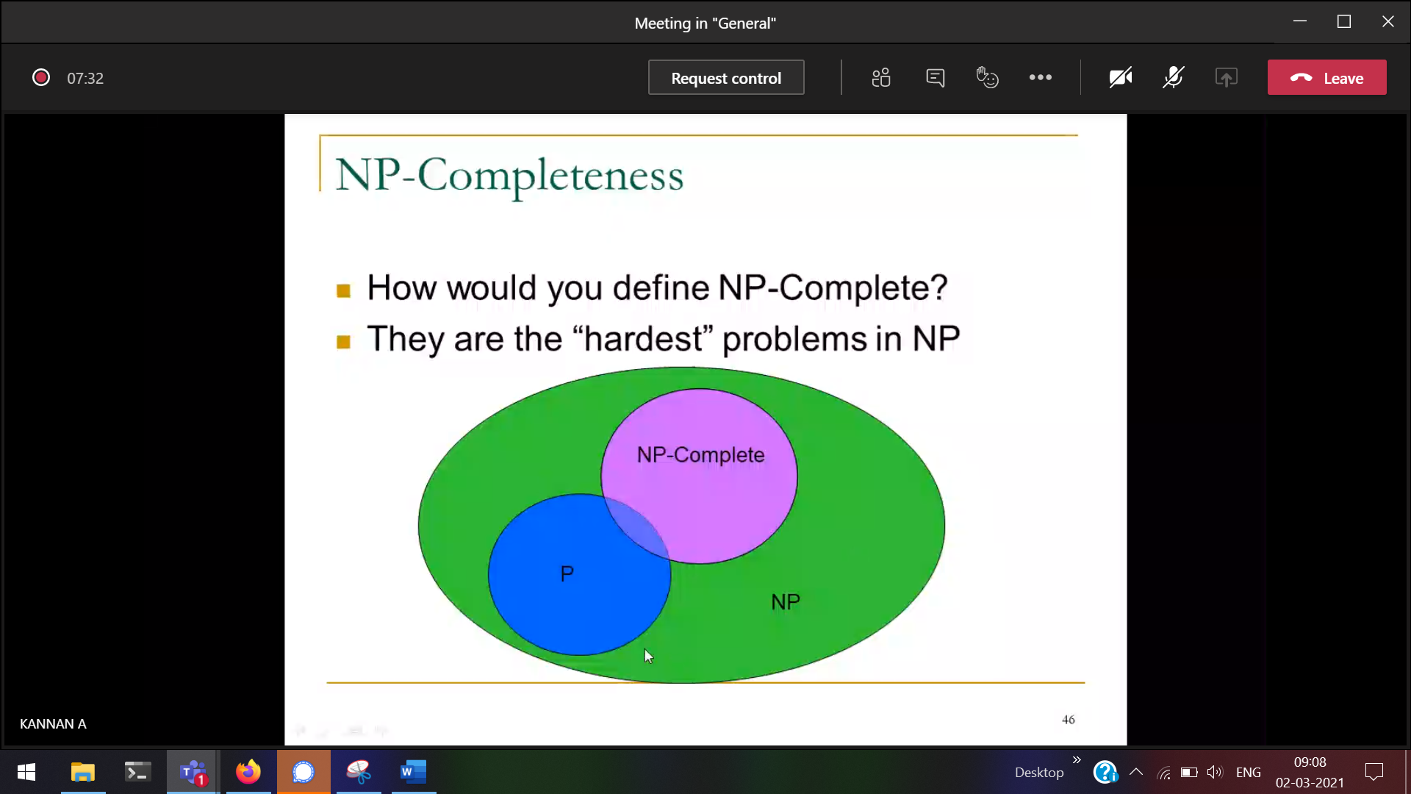

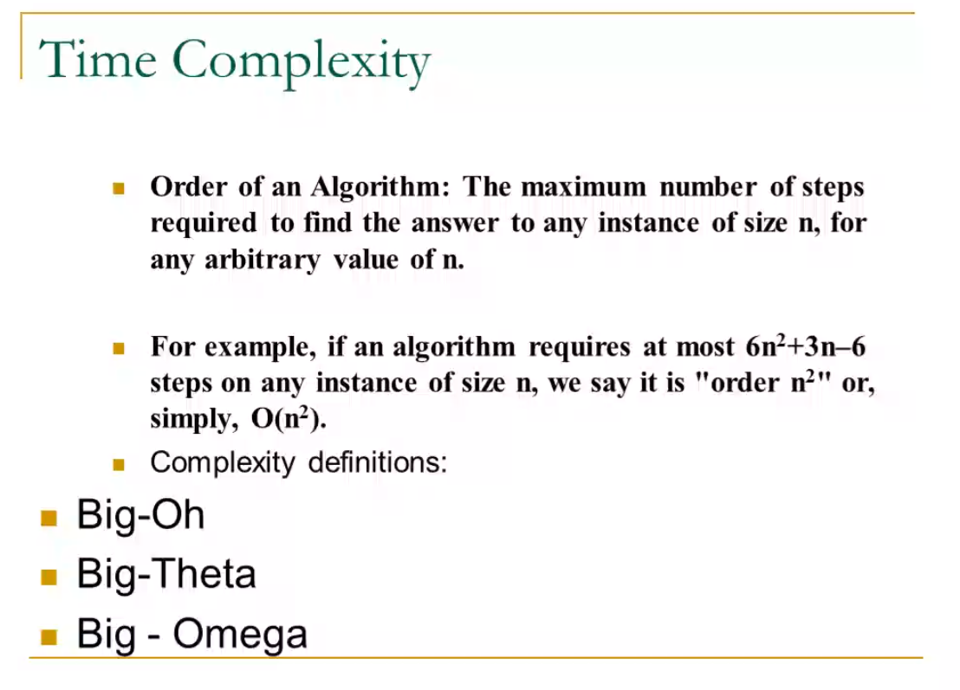

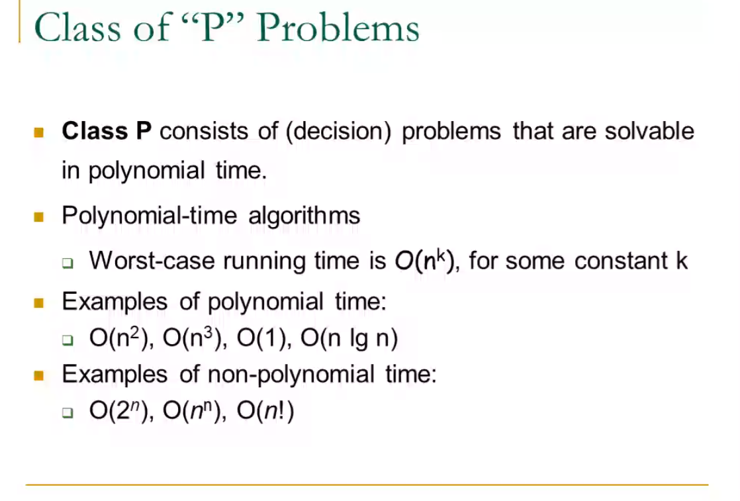



Square_root 🡪 is solvable but we cannot able to obtain a perfect square for a number

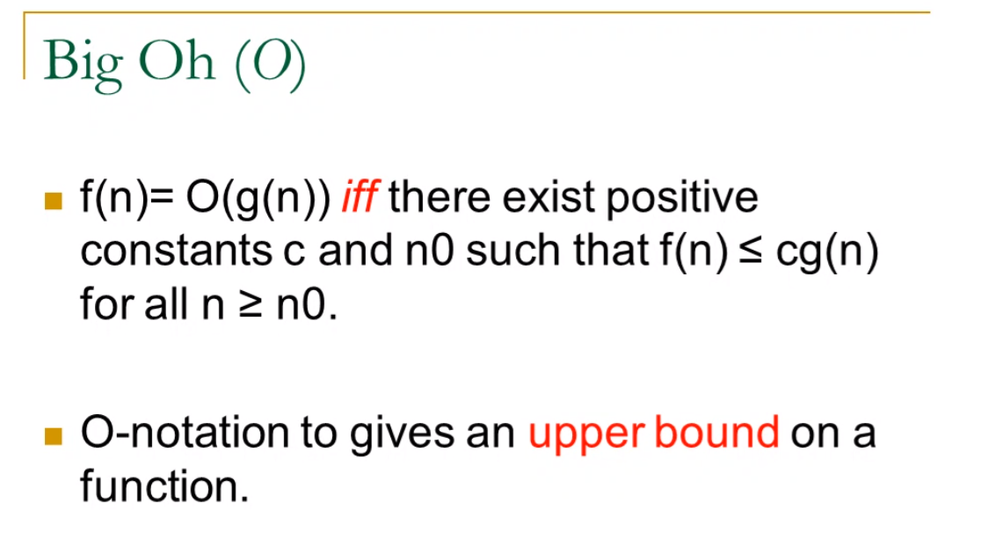



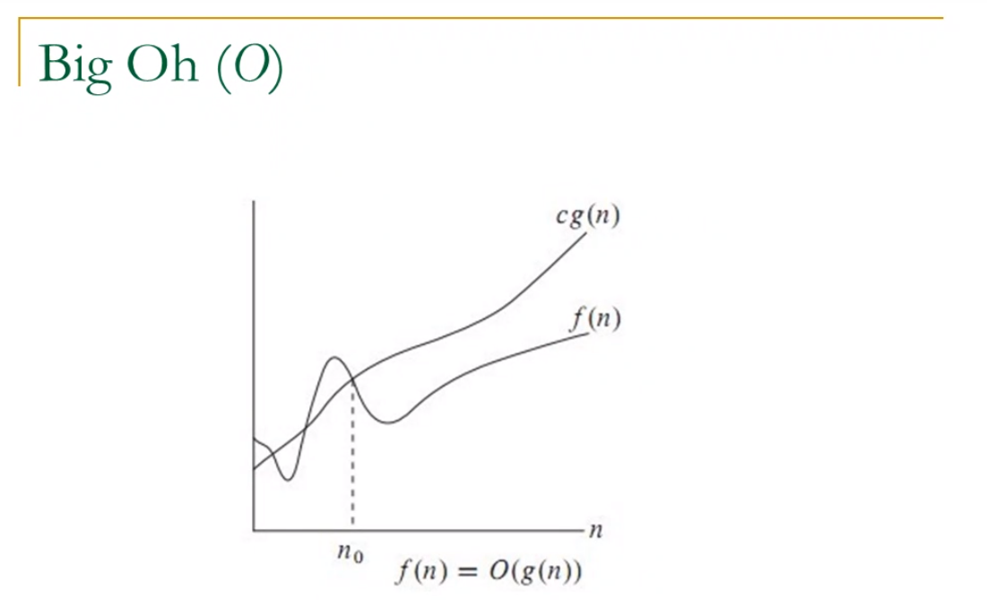



After no f(n) is always lesser than c*g(n)

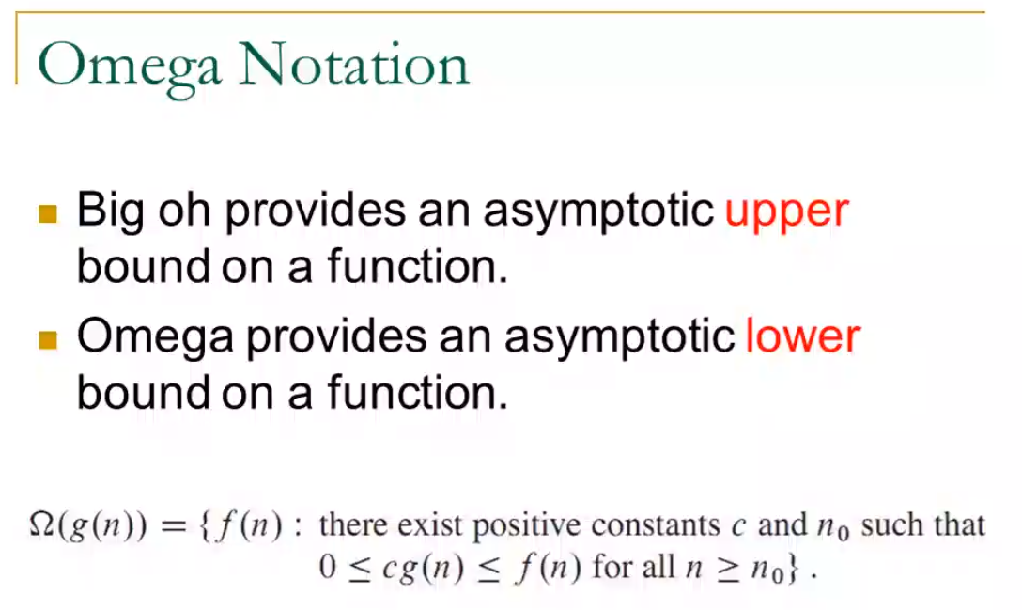

Eg: Pass mark (50 to 100)  
lower bound 🡪 50  
upper bound 🡪 100

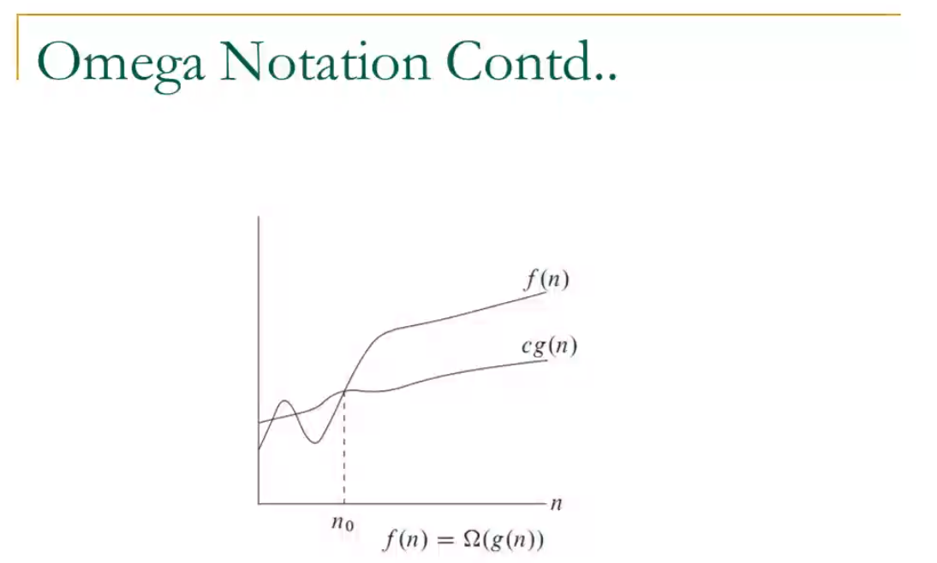

After no f(n) is greater than c*g(n)

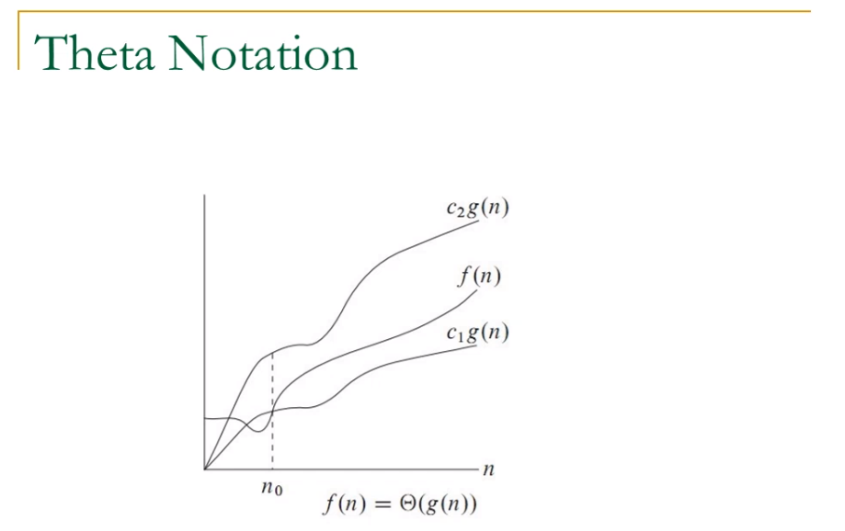

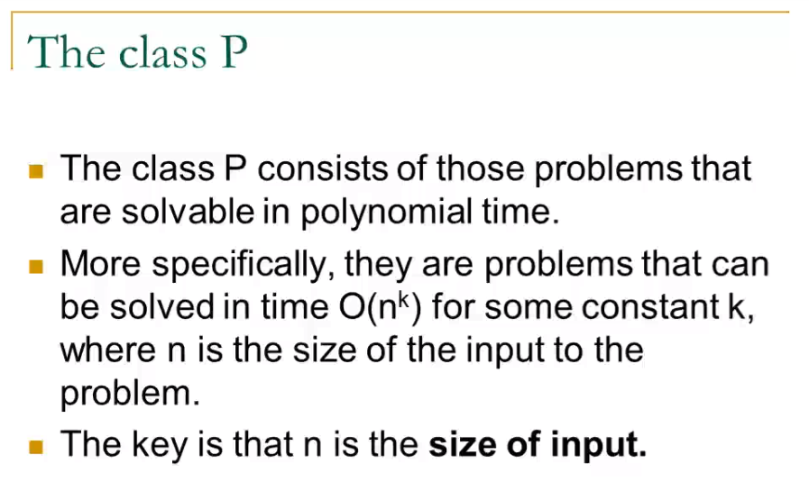

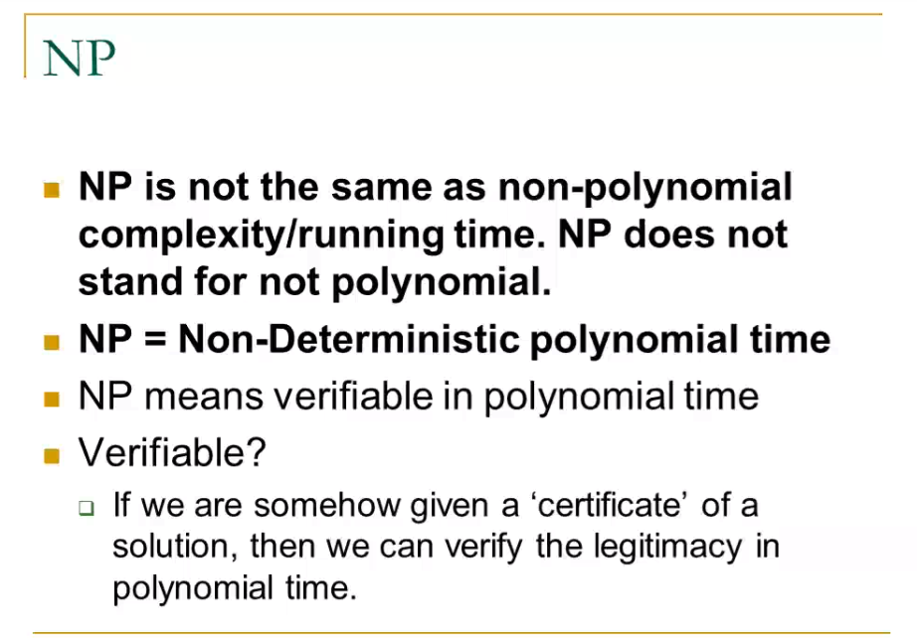

P 🡪 polynomial   
NP 🡪 Non-Deterministic Polynomial

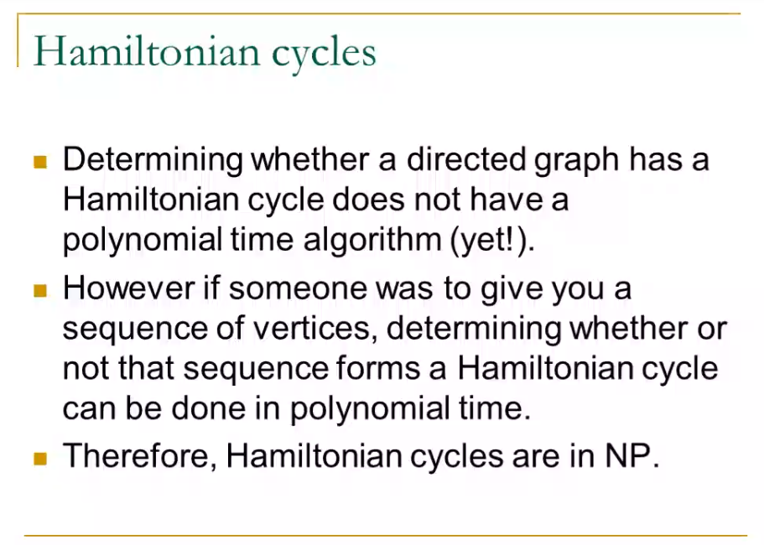

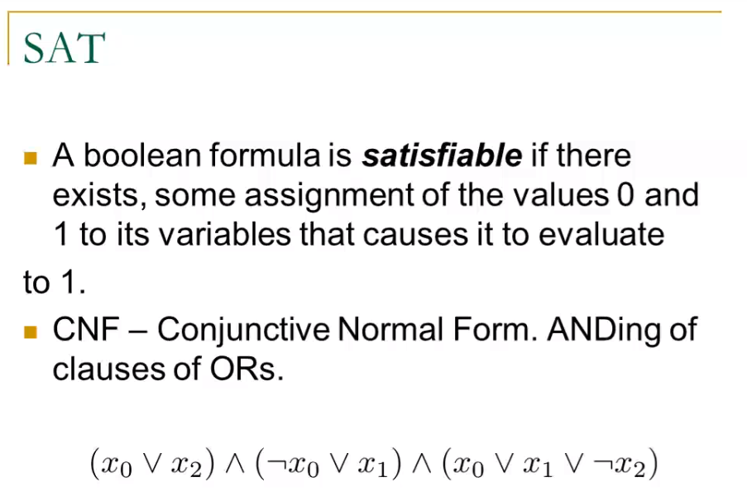



Conjunction of disjunction

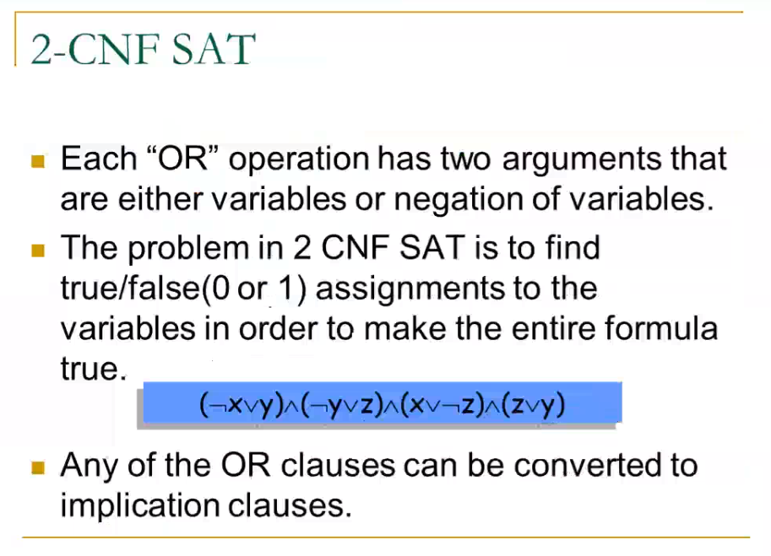



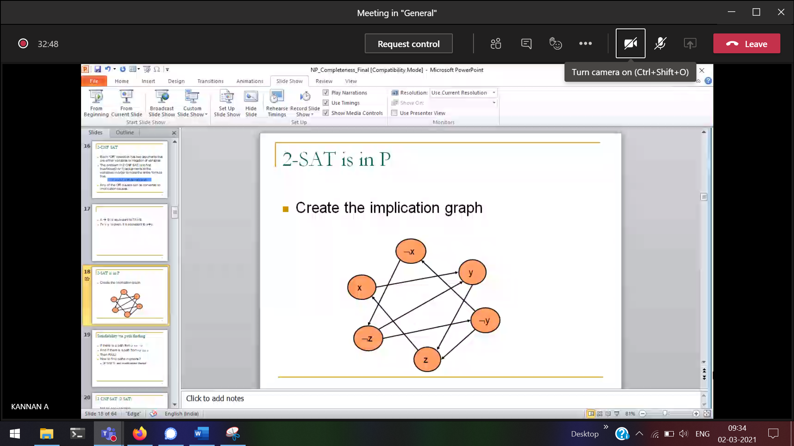

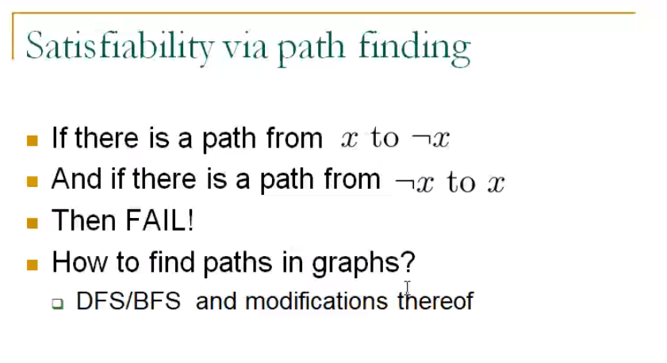

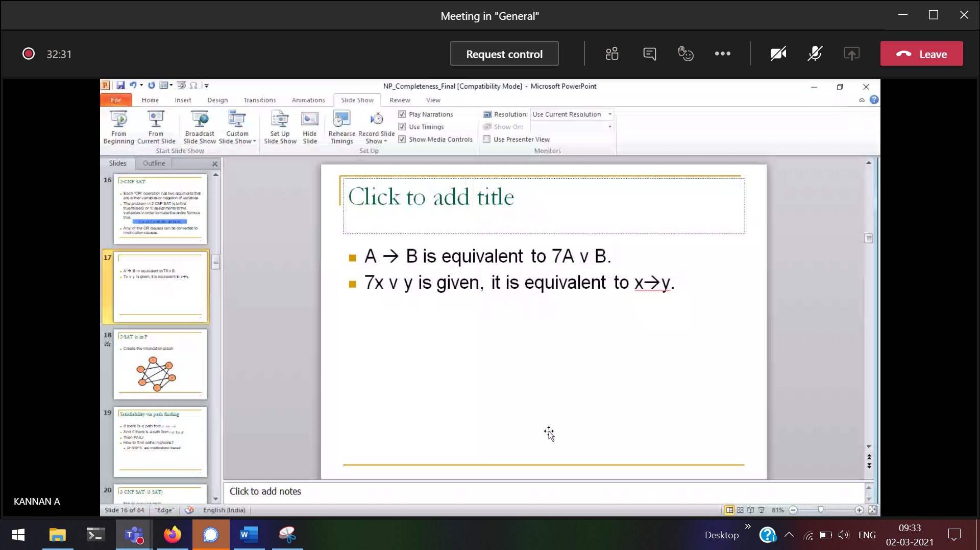

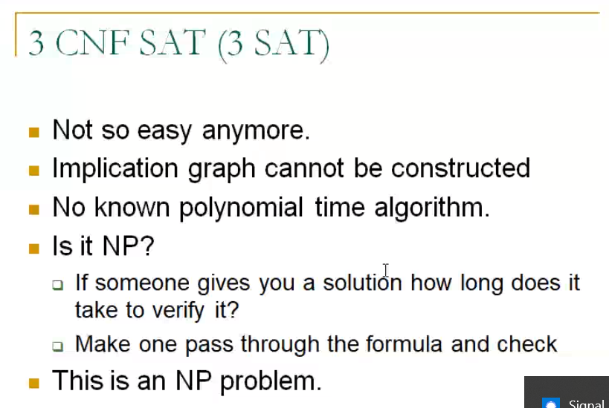

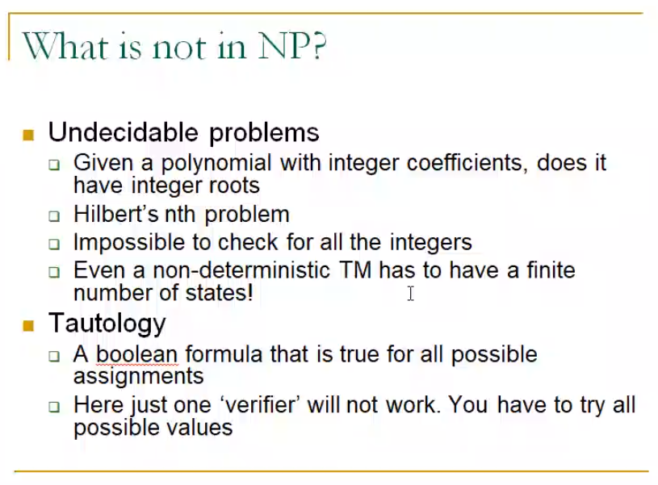

All quadratic polynomial 🡪 will not have Integer rule

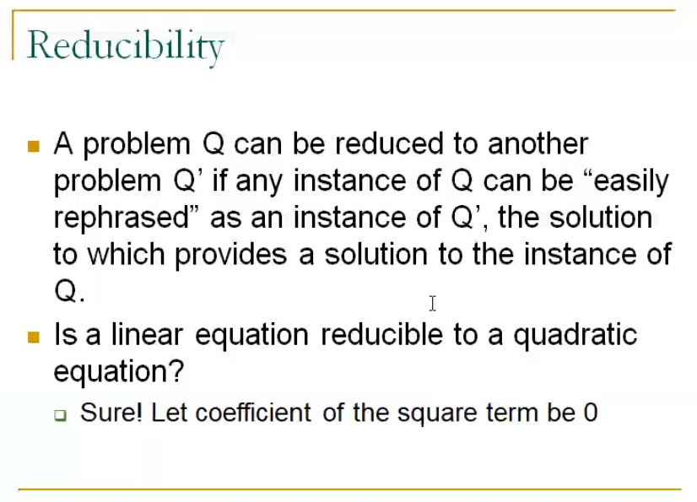



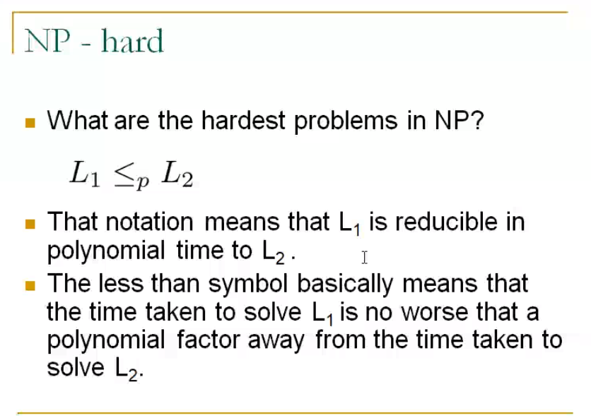

L1 🡪 1 problem  
L2 🡪 another problem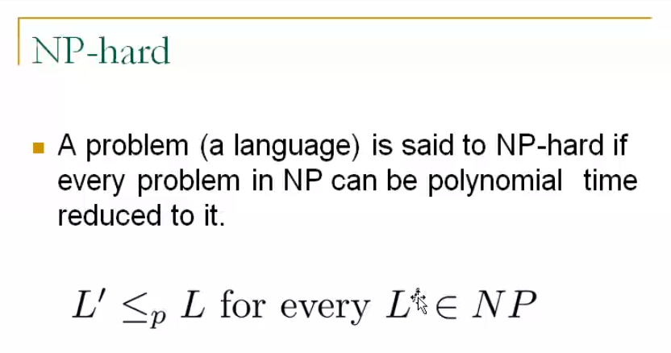

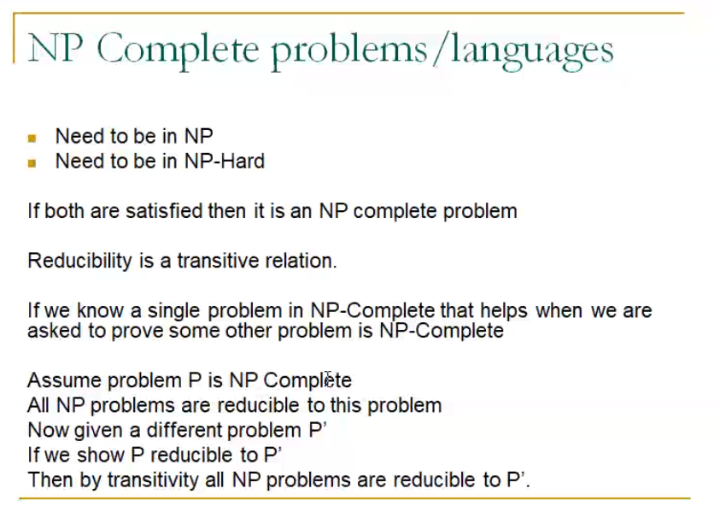

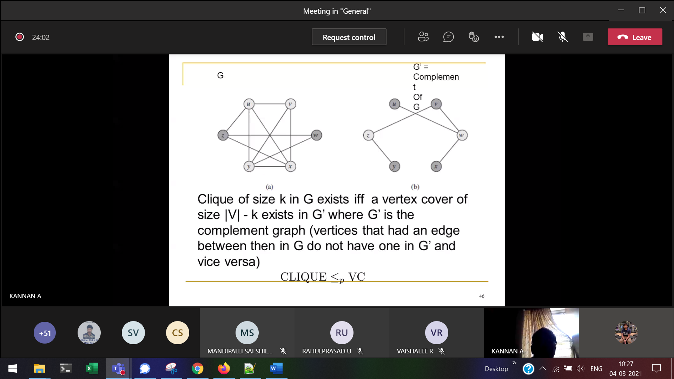

**Complement of a graph**